**Experiment 1**

**Aim:**

**To design a simple HTML form that collects basic user information such as name, email, and age, using fundamental HTML form elements like <form>, <label>, <input>, and <button>**

**Objective:**

The objective of this experiment is to understand how to create a basic HTML form.  
This form allows users to enter their name, email, and age, and includes a submit button.  
The experiment helps in understanding form controls such as <input>, <label>, and <button> in pure HTML without any styling.

**HTML Code:**

<!DOCTYPE html>

<html>

<head>

<title>Student Registration Form</title>

</head>

<body>

<h1>Student Registration Form</h1>

<form>

<label for="name">Name:</label><br>

<input type="text" id="name" name="name" placeholder="Enter your full name"><br><br>

<label for="email">Email:</label><br>

<input type="email" id="email" name="email" placeholder="Enter your email"><br><br>

<label for="age">Age:</label><br>

<input type="number" id="age" name="age" placeholder="Enter"><br><br>

<button type="submit">Register</button>

</form>

</body>

</html>

**Output:**

The output displays a simple form with:

* A **heading**: “Student Registration Form”
* A **text field** for entering the name
* An **email field** for entering the email address
* A **number input** for the age
* A **submit button** labeled “Register”

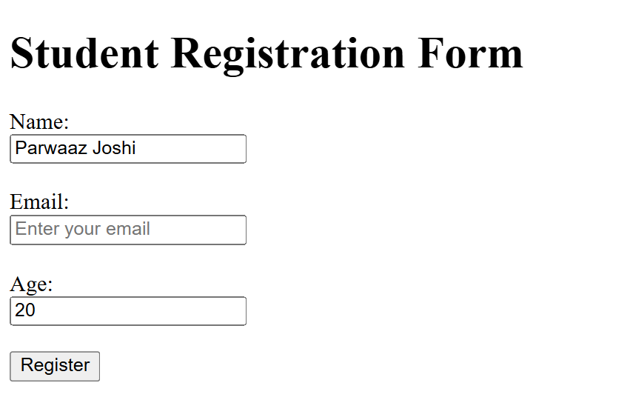

**Submitted by:**

**Name:** Parwaaz Joshi  
**UID:** 23BIS70101